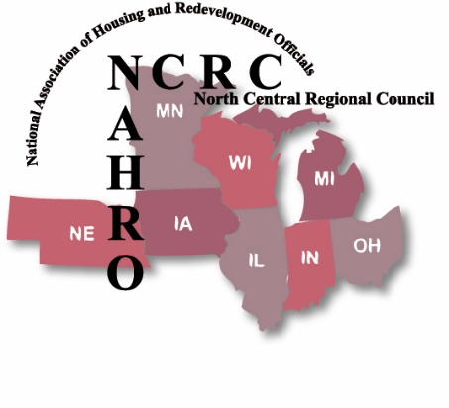
Media Images & Photography Opt-Out Form
I do not authorize North Central Regional Council of NAHRO or its officers, employees, or agents, to use recordings or photographs of myself in whole or part for advertising, media, video, audio, or other marketing purposes of NCRC NAHRO. I hereby confirm that I am of legal age (over 18) and have every right to contract in my own name. I further affirm that I have read the above “Media Images Opt-Out Release” and am familiar with its contents. I have provided a picture of myself to be used as reference to assure my dis-inclusion in any images used by NCRC NAHRO. I will notify photographers in my vicinity that I do not wish to be photographed. In signing this Form, I understand that NCRC NAHRO will make reasonable efforts to avoid access to, or remove, my image or voice for all purposes identified herein.
Adult (Over 18)
Date: Name:
Address:
City: State: _______ Zip:
Phone: Email:
Child (Under 18)
Date: Child’s name:
Parent’s Name:
Phone: Email:
I hereby confirm that I am the Parent or Guardian I further affirm I have read the above “Media Images Opt-Out Release,” and am familiar with its contents.
Signature:
Return this form including a reference photo to the NCRC NAHRO Office attention Cheryl Anne Farmer, rso@ncrcnaharo.org. or: NCRC NAHRO, 169 Templar Ave., Pinckney, MI 48169
Office Use: Photo Received By:
Date:

